Anomaly Analysis with LLM to support understanding of explanations and cyber situations
Contents
2nd Level Decision Fusion Anomaly Log 1
Analysis – Fused Anomaly 1
Prompt to Gemini 2.0 Flash – Fused Anomaly 4
Follow up prompt (“Do you think it is APT attack?”) 5
Response to follow-up prompt 5
Individual Log Analysis - Host Log 8
Analysis – Host Anomaly 8
Prompt to Gemini 2.0 Flash – Host Anomaly 10
Individual Log Analysis - Network Log 22
Analysis – Network Anomaly 22
Prompt to Gemini 2.0 Flash – Network Anomaly 23
Individual Log Analysis - Process Log 29
Analysis – Process Anomaly 29
Prompt to Gemini 2.0 Flash – Process Anomaly 30

2nd Level Decision Fusion Anomaly Log

Analysis – Fused Anomaly
- Query successful
Okay, I've analyzed the anomaly logs from May 9, 2025. Here's a summary of the information, focusing on a general overview and a breakdown of suspicious events by time range:
General Overview
The logs indicate a series of anomaly detections across both the OT network and IT host systems throughout the day. The anomalies observed can be broadly categorized as:
- OT Network and Process Anomalies: These are often related to unusual patterns in OPC UA message sizes and process behavior, including deviations in the number of unique write targets and specific Node IDs written. Some of these anomalies are specifically flagged due to process scores exceeding a threshold or the triggering of process alarms.
- Host Anomalies: These anomalies involve suspicious activities on the IT hosts, such as NTLM logon attempts (potential relay attacks), suspicious logon processes, the assignment of special privileges, command prompt activities, PowerShell script execution, and detection of potentially unwanted software by Windows Defender.
Summary of Suspicious Events by Time Range
Here's a breakdown of notable events, focusing on potentially suspicious activity:
- 14:38 - 15:04: Initial OT network and process anomalies are detected, characterized by unusual OPC UA message sizes.
- 15:05 - 15:19: A mix of OT network/process and host anomalies. Host anomalies begin to show signs of suspicious activity, including command prompt execution by a suspicious process, NTLM logon attempts, and potential pass-the-hash logins.
- 15:21 - 15:31: Host anomalies escalate with repeated NTLM logon attempts, suspicious PowerShell scripts, web request downloads, and Windows Defender detecting and blocking threats. There's also an indication of a binary being dropped in the Users\Public directory. The host anomaly score reaches a high value of 118 at 15:31.
- 15:33 - 15:59: Continued host anomalies with NTLM activity and command shell executions. OT network anomalies persist, and process anomalies begin to highlight unusual write targets and process alarms.
- 16:00 - 16:15: Both OT network/process and host anomalies are observed, with a focus on unusual process behavior in the OT environment and continued high severity host anomalies.
Overall, the timeline suggests a potential intrusion or escalating series of anomalous events starting in the OT network and then significantly impacting the IT host environment, with a variety of suspicious logon activities, script executions, and malware detections.
Related screenshot of the Gemini 2.0 Flash system
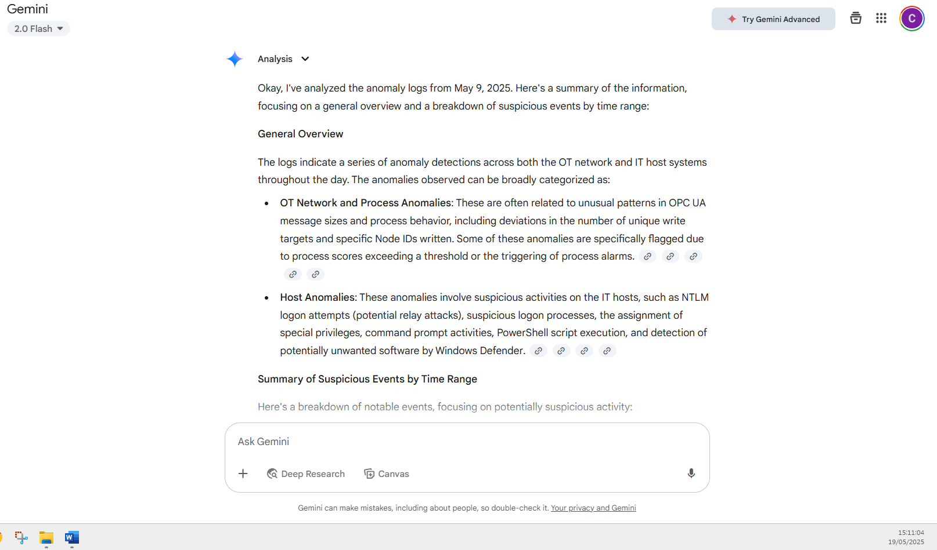
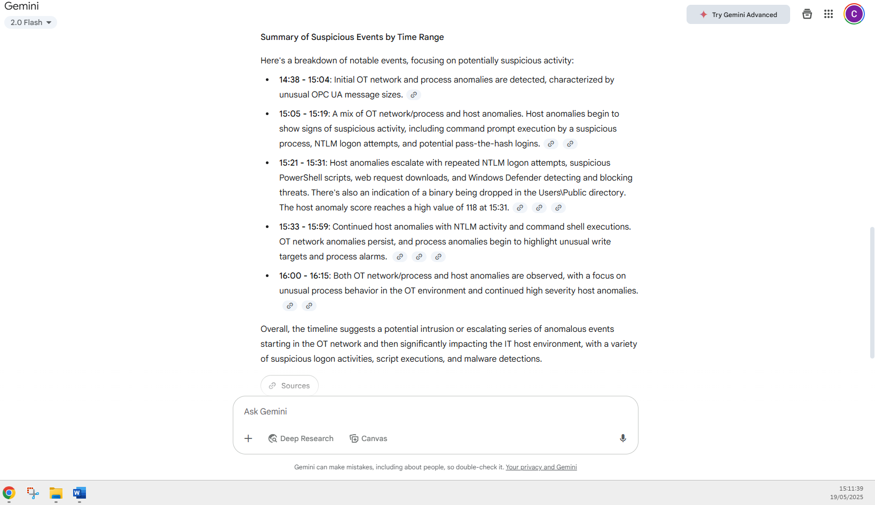

Prompt to Gemini 2.0 Flash – Fused Anomaly
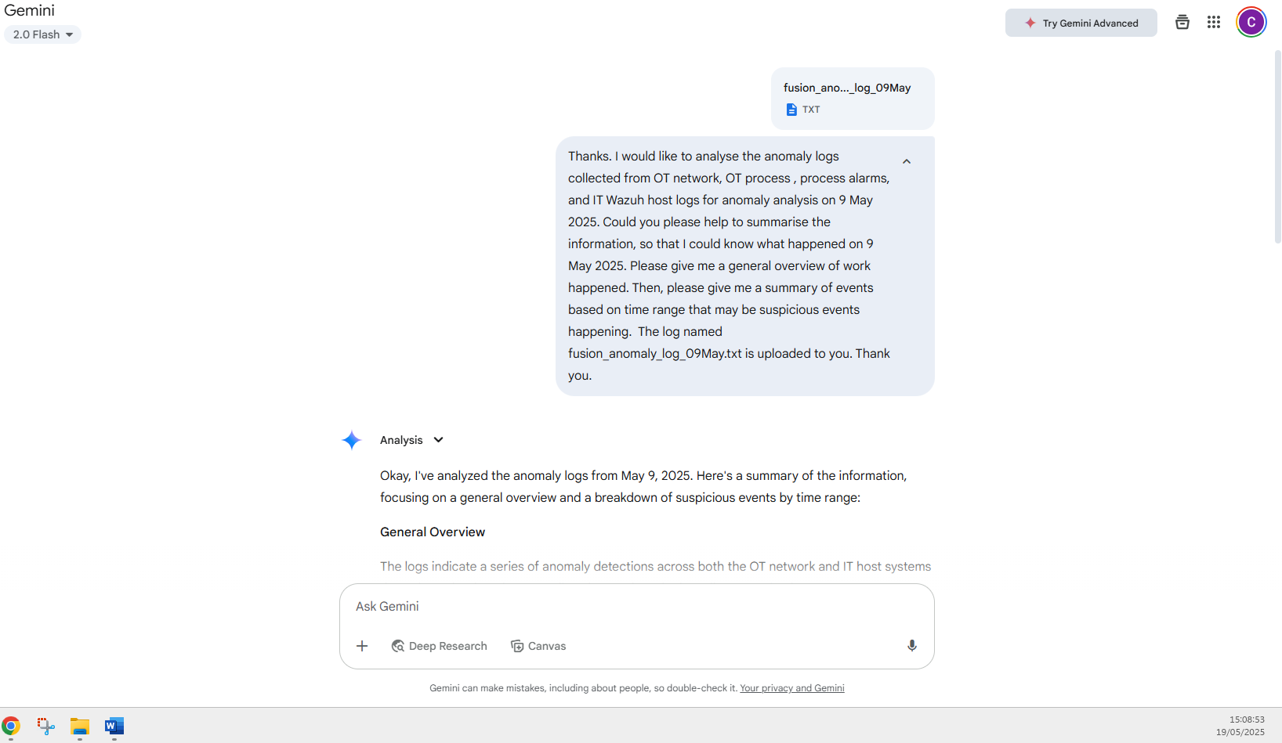
Thanks. I would like to analyse the anomaly logs collected from OT network, OT process , process alarms, and IT Wazuh host logs for anomaly analysis on 9 May 2025. Could you please help to summarise the information, so that I could know what happened on 9 May 2025. Please give me a general overview of work happened. Then, please give me a summary of events based on time range that may be suspicious events happening. The log named fusion_anomaly_log_09May.txt is uploaded to you. Thank you.
# Note: file ‘fusion_anomaly_log_09May.txt’ is to be uploaded to Gemini 2.0 Flash.

Follow up prompt (“Do you think it is APT attack?”)
Do you think it is APT attack?
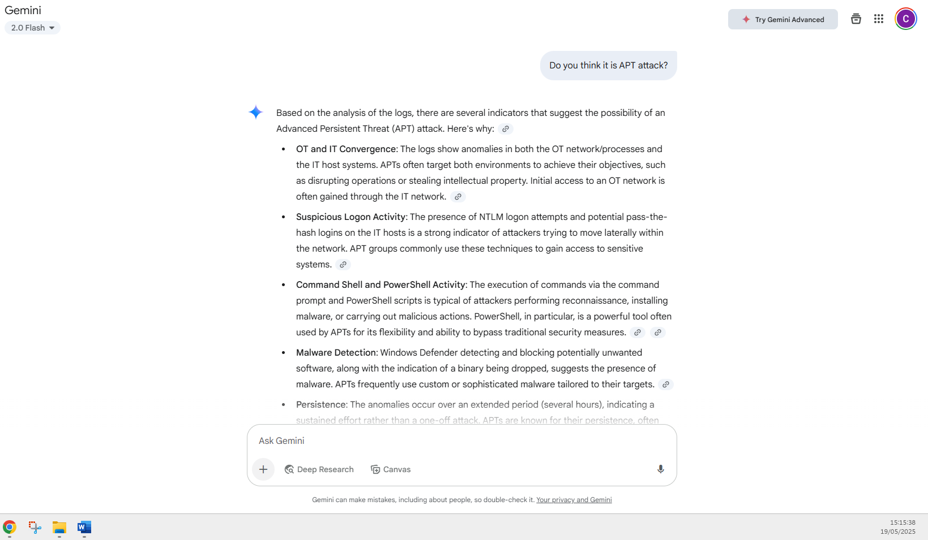

Response to follow-up prompt
Based on the analysis of the logs, there are several indicators that suggest the possibility of an Advanced Persistent Threat (APT) attack. Here's why:
- OT and IT Convergence: The logs show anomalies in both the OT network/processes and the IT host systems. APTs often target both environments to achieve their objectives, such as disrupting operations or stealing intellectual property. Initial access to an OT network is often gained through the IT network.
- Suspicious Logon Activity: The presence of NTLM logon attempts and potential pass-the-hash logins on the IT hosts is a strong indicator of attackers trying to move laterally within the network. APT groups commonly use these techniques to gain access to sensitive systems.
- Command Shell and PowerShell Activity: The execution of commands via the command prompt and PowerShell scripts is typical of attackers performing reconnaissance, installing malware, or carrying out malicious actions. PowerShell, in particular, is a powerful tool often used by APTs for its flexibility and ability to bypass traditional security measures.
- Malware Detection: Windows Defender detecting and blocking potentially unwanted software, along with the indication of a binary being dropped, suggests the presence of malware. APTs frequently use custom or sophisticated malware tailored to their targets.
- Persistence: The anomalies occur over an extended period (several hours), indicating a sustained effort rather than a one-off attack. APTs are known for their persistence, often maintaining a presence in a compromised network for long periods.
- Specific Targeting: The targeting of OPC UA communications within the OT environment suggests a specific interest in industrial control systems. APTs targeting OT environments often have the goal of disrupting critical infrastructure or industrial processes.
While the logs provide strong indicators of a potential APT attack, a definitive determination would require further investigation, including:
- Log Correlation: Correlating these logs with other security data sources to get a more complete picture.
- Malware Analysis: Analyzing any detected malware to understand its capabilities and origin.
- Network Forensics: Examining network traffic for signs of command-and-control communication or data exfiltration.
- Host Forensics: Performing in-depth analysis of the affected host systems to identify the extent of the compromise and the attacker's actions.
In summary, the combination of OT/IT targeting, suspicious logon activity, command shell usage, malware detection, and persistence strongly suggests that the events on May 9, 2025, could be indicative of an APT attack.
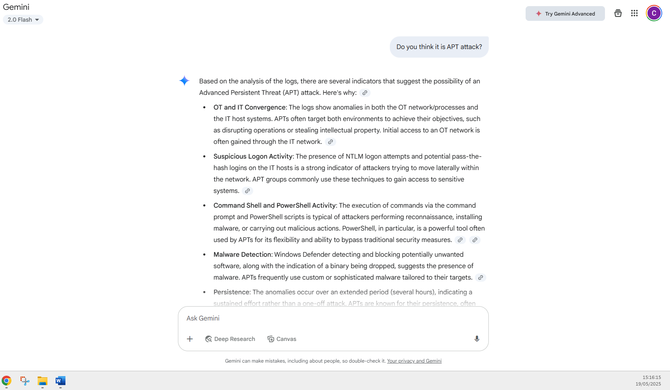
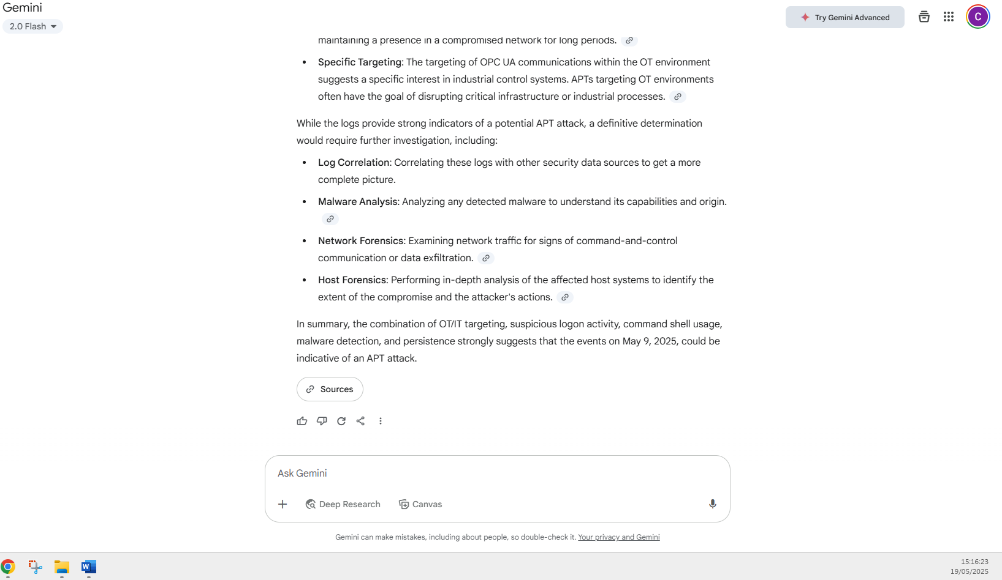
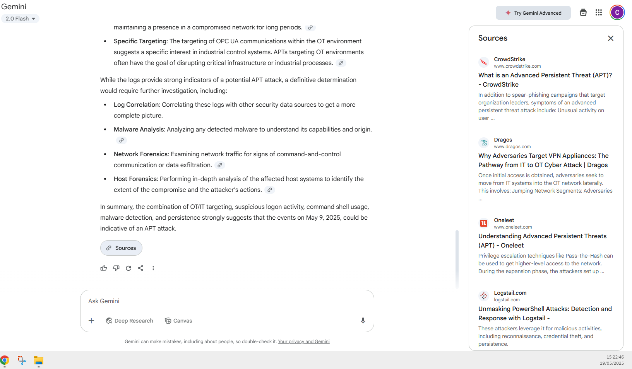

Individual Log Analysis - Host Log

Analysis – Host Anomaly
Certainly, let's break down these Wazuh anomaly logs from May 9, 2025.
General Overview of Activity
The logs indicate a significant spike in suspicious activity starting around 14:00 and intensifying between 15:00 and 16:39. The primary indicators revolve around potentially compromised or misused NTLM authentication, suspicious command-line and PowerShell activity, and the detection of potentially unwanted software by Windows Defender. There are also numerous instances of Wazuh rules at level 7 or above being triggered, suggesting various security concerns were raised. Towards the end of the logged period, the intensity of the alerts seems to decrease, but suspicious logon attempts and command-line activity persist.
Summary of Potentially Suspicious Events by Time Range (Starting 14:00)
Based on the anomaly scores and the nature of the explanations, the following time ranges appear to be the most critical and warrant further investigation:
- 14:00 - 14:31: This initial period shows the emergence of suspicious logon processes, the execution of commands via the command prompt by suspicious processes, and PowerShell being used to delete files. The triggering of Wazuh rules at a medium to high severity level during this time further emphasizes the potential severity.
- 14:58 - 15:19: While there are some isolated medium/high severity Wazuh rule triggers, the activity escalates significantly around 15:07. This timeframe is dominated by repeated alerts of potential NTLM relay attacks and pass-the-hash logins, often accompanied by suspicious logon processes and the assignment of special privileges. Notably, Windows Defender starts detecting and blocking potential threats within this period.
- 15:24 - 15:31: This short burst of activity shows a concerning progression. Alongside the continued NTLM-related anomalies, we see indicators of a binary being placed in a malware-prone directory, suspicious PowerShell scripts being executed, and ultimately, a binary being dropped in the Users\Public directory after a web request download cradle and PowerShell archive expansion. The anomaly score of 118 at 15:31 is exceptionally high and demands immediate attention.
- 15:35 - 16:39: This extended period continues to show high anomaly scores, primarily driven by persistent NTLM-related suspicious activities. Additionally, there are alerts regarding command-line execution from unusual parent processes, remote execution via net.exe, PowerShell querying environment variables, and even reconfiguration of a Windows installer product. Towards the later part of this range (around 16:15 onwards), there's a resurgence of very high anomaly scores, accompanied by indicators of binaries being dropped in the Windows root directory and the creation of new suspicious Windows services. The repeated occurrence of these high-scoring events suggests a sustained and potentially automated malicious activity.
In summary, May 9, 2025, saw a significant security event unfold, characterized by suspicious authentication attempts, command execution, potential malware deployment, and Windows Defender actively responding to threats. The timeframes between 15:00 and 16:39 appear to be particularly critical and should be the focus of your immediate analysis.

Prompt to Gemini 2.0 Flash – Host Anomaly
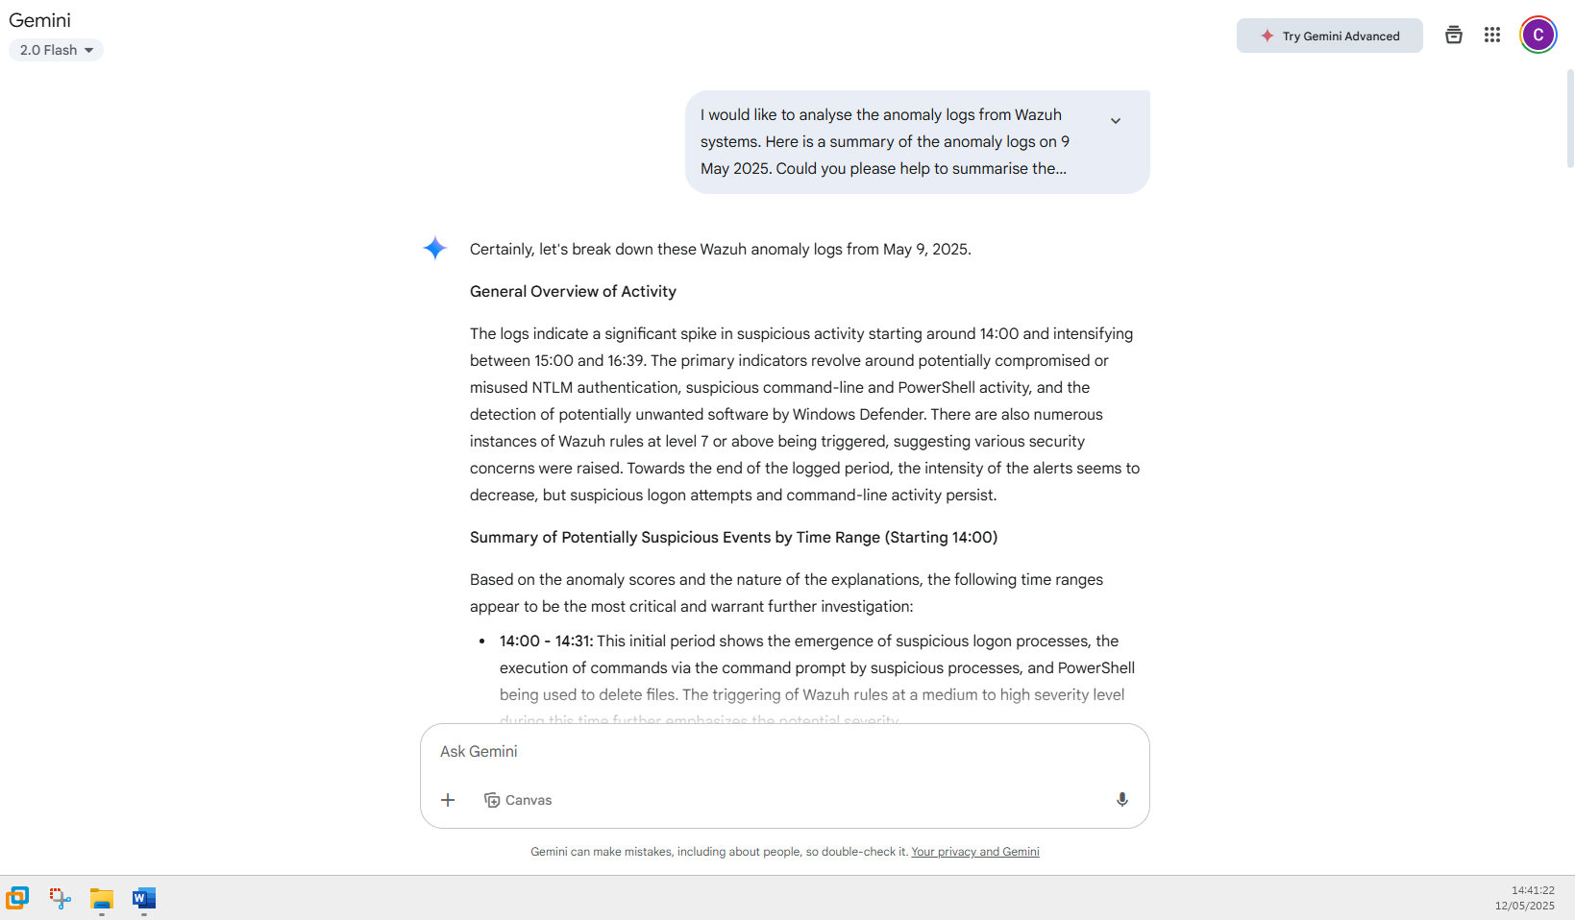
I would like to analyse the anomaly logs from Wazuh systems. Here is a summary of the anomaly logs on 9 May 2025. Could you please help to summarise the information, so that I could know what has happened during the 9 May 2025. Please give me a general overview of work happened. Then, please give me a summary of events based on time range that may be suspicious events happening. Time 2025-05-09 14:00
Anomaly Score: 6
Explanation: Suspicious logon process (user32 or NtLmSsp); Special privileges assigned to logon [T1484]
------------------------------------------------------------
Time 2025-05-09 14:04
Anomaly Score: 12
Explanation: cmd prompt started by suspicious process [T1059.003]
------------------------------------------------------------
Time 2025-05-09 14:12
Anomaly Score: 4
Explanation: Wazuh rule level 7 or above (medium/high severity)
------------------------------------------------------------
Time 2025-05-09 14:13
Anomaly Score: 2
Explanation: Wazuh rule level 7 or above (medium/high severity)
------------------------------------------------------------
Time 2025-05-09 14:28
Anomaly Score: 12
Explanation: PowerShell deletes files [T1070.004]; Wazuh rule level 7 or above (medium/high severity)
------------------------------------------------------------
Time 2025-05-09 14:29
Anomaly Score: 14
Explanation: PowerShell deletes files [T1070.004]; Wazuh rule level 7 or above (medium/high severity)
------------------------------------------------------------
Time 2025-05-09 14:31
Anomaly Score: 2
Explanation: Suspicious PowerShell script (4104)
------------------------------------------------------------
Time 2025-05-09 14:58
Anomaly Score: 2
Explanation: Wazuh rule level 7 or above (medium/high severity)
------------------------------------------------------------
Time 2025-05-09 15:00
Anomaly Score: 2
Explanation: Wazuh rule level 7 or above (medium/high severity)
------------------------------------------------------------
Time 2025-05-09 15:05
Anomaly Score: 4
Explanation: cmd prompt started by suspicious process [T1059.003]
------------------------------------------------------------
Time 2025-05-09 15:07
Anomaly Score: 12
Explanation: NTLM logon (potential relay attack); Suspicious logon process (user32 or NtLmSsp); NTLM pass-the-hash login [T1550.002]
------------------------------------------------------------
Time 2025-05-09 15:09
Anomaly Score: 10
Explanation: NTLM logon (potential relay attack); Suspicious logon process (user32 or NtLmSsp); NTLM pass-the-hash login [T1550.002]
------------------------------------------------------------
Time 2025-05-09 15:10
Anomaly Score: 22
Explanation: NTLM logon (potential relay attack); Suspicious logon process (user32 or NtLmSsp); Special privileges assigned to logon [T1484]; NTLM pass-the-hash login [T1550.002]
------------------------------------------------------------
Time 2025-05-09 15:11
Anomaly Score: 22
Explanation: NTLM logon (potential relay attack); Suspicious logon process (user32 or NtLmSsp); Special privileges assigned to logon [T1484]; NTLM pass-the-hash login [T1550.002]
------------------------------------------------------------
Time 2025-05-09 15:12
Anomaly Score: 28
Explanation: NTLM logon (potential relay attack); Suspicious logon process (user32 or NtLmSsp); Special privileges assigned to logon [T1484]; NTLM pass-the-hash login [T1550.002]
------------------------------------------------------------
Time 2025-05-09 15:13
Anomaly Score: 20
Explanation: NTLM logon (potential relay attack); Suspicious logon process (user32 or NtLmSsp); Special privileges assigned to logon [T1484]; NTLM pass-the-hash login [T1550.002]
------------------------------------------------------------
Time 2025-05-09 15:14
Anomaly Score: 20
Explanation: NTLM logon (potential relay attack); Suspicious logon process (user32 or NtLmSsp); Special privileges assigned to logon [T1484]; NTLM pass-the-hash login [T1550.002]; Windows Defender detected Win32 threat; Defender found potentially unwanted software; Wazuh rule level 7 or above (medium/high severity)
------------------------------------------------------------
Time 2025-05-09 15:15
Anomaly Score: 18
Explanation: NTLM logon (potential relay attack); Suspicious logon process (user32 or NtLmSsp); Special privileges assigned to logon [T1484]; NTLM pass-the-hash login [T1550.002]; Windows Defender detected Win32 threat; Defender blocked unwanted software
------------------------------------------------------------
Time 2025-05-09 15:16
Anomaly Score: 6
Explanation: Windows Defender detected Win32 threat; Defender found potentially unwanted software; Wazuh rule level 7 or above (medium/high severity)
------------------------------------------------------------
Time 2025-05-09 15:17
Anomaly Score: 24
Explanation: NTLM logon (potential relay attack); Suspicious logon process (user32 or NtLmSsp); NTLM pass-the-hash login [T1550.002]; Windows Defender detected Win32 threat; Defender blocked unwanted software
------------------------------------------------------------
Time 2025-05-09 15:18
Anomaly Score: 12
Explanation: NTLM logon (potential relay attack); Suspicious logon process (user32 or NtLmSsp); NTLM pass-the-hash login [T1550.002]
------------------------------------------------------------
Time 2025-05-09 15:19
Anomaly Score: 14
Explanation: NTLM logon (potential relay attack); Suspicious logon process (user32 or NtLmSsp); Special privileges assigned to logon [T1484]; NTLM pass-the-hash login [T1550.002]
------------------------------------------------------------
Time 2025-05-09 15:21
Anomaly Score: 14
Explanation: NTLM logon (potential relay attack); Suspicious logon process (user32 or NtLmSsp); Special privileges assigned to logon [T1484]; NTLM pass-the-hash login [T1550.002]
------------------------------------------------------------
Time 2025-05-09 15:24
Anomaly Score: 12
Explanation: NTLM logon (potential relay attack); Suspicious logon process (user32 or NtLmSsp); Special privileges assigned to logon [T1484]; NTLM pass-the-hash login [T1550.002]; Binary in malware-prone directory [T1105]; Wazuh rule level 7 or above (medium/high severity)
------------------------------------------------------------
Time 2025-05-09 15:25
Anomaly Score: 16
Explanation: NTLM logon (potential relay attack); Suspicious logon process (user32 or NtLmSsp); Special privileges assigned to logon [T1484]; NTLM pass-the-hash login [T1550.002]
------------------------------------------------------------
Time 2025-05-09 15:26
Anomaly Score: 12
Explanation: NTLM logon (potential relay attack); Suspicious logon process (user32 or NtLmSsp); Special privileges assigned to logon [T1484]; NTLM pass-the-hash login [T1550.002]; Suspicious PowerShell script (4104); PowerShell process discovery [T1057]
------------------------------------------------------------
Time 2025-05-09 15:27
Anomaly Score: 16
Explanation: NTLM logon (potential relay attack); Suspicious logon process (user32 or NtLmSsp); Special privileges assigned to logon [T1484]; NTLM pass-the-hash login [T1550.002]
------------------------------------------------------------
Time 2025-05-09 15:29
Anomaly Score: 20
Explanation: NTLM logon (potential relay attack); Suspicious logon process (user32 or NtLmSsp); Special privileges assigned to logon [T1484]; NTLM pass-the-hash login [T1550.002]; Windows Defender detected Win32 threat; Defender found potentially unwanted software; Wazuh rule level 7 or above (medium/high severity)
------------------------------------------------------------
Time 2025-05-09 15:30
Anomaly Score: 22
Explanation: NTLM logon (potential relay attack); Suspicious logon process (user32 or NtLmSsp); Special privileges assigned to logon [T1484]; NTLM pass-the-hash login [T1550.002]; Webrequest download cradle [T1059.001]; Windows Defender detected Win32 threat; Defender blocked unwanted software
------------------------------------------------------------
Time 2025-05-09 15:31
Anomaly Score: 118
Explanation: NTLM logon (potential relay attack); Suspicious logon process (user32 or NtLmSsp); Special privileges assigned to logon [T1484]; NTLM pass-the-hash login [T1550.002]; Suspicious PowerShell script (4104); PowerShell Expand-Archive run [T1105]; Webrequest download cradle [T1059.001]; Binary dropped in Users\Public; Wazuh rule level 7 or above (medium/high severity)
------------------------------------------------------------
Time 2025-05-09 15:33
Anomaly Score: 8
Explanation: NTLM logon (potential relay attack); Suspicious logon process (user32 or NtLmSsp); Special privileges assigned to logon [T1484]; NTLM pass-the-hash login [T1550.002]
------------------------------------------------------------
Time 2025-05-09 15:35
Anomaly Score: 52
Explanation: NTLM logon (potential relay attack); Suspicious logon process (user32 or NtLmSsp); Special privileges assigned to logon [T1484]; NTLM pass-the-hash login [T1550.002]; cmd.exe launched by unusual parent process; Suspicious Windows cmd shell exec [T1087/T1059.003]
------------------------------------------------------------
Time 2025-05-09 15:36
Anomaly Score: 4
Explanation: cmd.exe launched by unusual parent process; Suspicious Windows cmd shell exec [T1087/T1059.003]
------------------------------------------------------------
Time 2025-05-09 15:41
Anomaly Score: 18
Explanation: NTLM logon (potential relay attack); Suspicious logon process (user32 or NtLmSsp); Special privileges assigned to logon [T1484]; NTLM pass-the-hash login [T1550.002]; Suspicious PowerShell script (4104); PowerShell queries env variables [T1082]; Windows installer reconfigured product
------------------------------------------------------------
Time 2025-05-09 15:42
Anomaly Score: 12
Explanation: NTLM logon (potential relay attack); Suspicious logon process (user32 or NtLmSsp); Special privileges assigned to logon [T1484]; NTLM pass-the-hash login [T1550.002]; Suspicious PowerShell script (4104); PowerShell queries env variables [T1082]
------------------------------------------------------------
Time 2025-05-09 15:44
Anomaly Score: 24
Explanation: NTLM logon (potential relay attack); Suspicious logon process (user32 or NtLmSsp); Special privileges assigned to logon [T1484]; NTLM pass-the-hash login [T1550.002]; Suspicious PowerShell script (4104); PowerShell queries env variables [T1082]
------------------------------------------------------------
Time 2025-05-09 15:45
Anomaly Score: 10
Explanation: NTLM logon (potential relay attack); Suspicious logon process (user32 or NtLmSsp); Special privileges assigned to logon [T1484]; Remote net.exe run via wsmprovhost [T1567]; NTLM pass-the-hash login [T1550.002]
------------------------------------------------------------
Time 2025-05-09 15:46
Anomaly Score: 12
Explanation: NTLM logon (potential relay attack); Suspicious logon process (user32 or NtLmSsp); Special privileges assigned to logon [T1484]; NTLM pass-the-hash login [T1550.002]; Suspicious PowerShell script (4104); PowerShell queries env variables [T1082]
------------------------------------------------------------
Time 2025-05-09 15:47
Anomaly Score: 38
Explanation: NTLM logon (potential relay attack); Suspicious logon process (user32 or NtLmSsp); Special privileges assigned to logon [T1484]; Remote net.exe run via wsmprovhost [T1567]; NTLM pass-the-hash login [T1550.002]; Suspicious PowerShell script (4104); PowerShell queries env variables [T1082]
------------------------------------------------------------
Time 2025-05-09 15:52
Anomaly Score: 8
Explanation: NTLM logon (potential relay attack); Suspicious logon process (user32 or NtLmSsp); Special privileges assigned to logon [T1484]; NTLM pass-the-hash login [T1550.002]
------------------------------------------------------------
Time 2025-05-09 15:58
Anomaly Score: 40
Explanation: NTLM logon (potential relay attack); Suspicious logon process (user32 or NtLmSsp); Non-network/service logon detected; Special privileges assigned to logon [T1484]; RDP connection detected [T1021.001]; NTLM or RDP remote logon [T1550.002 / T1078.002]; Wazuh rule level 7 or above (medium/high severity)
------------------------------------------------------------
Time 2025-05-09 16:00
Anomaly Score: 2
Explanation: Wazuh rule level 7 or above (medium/high severity)
------------------------------------------------------------
Time 2025-05-09 16:05
Anomaly Score: 4
Explanation: cmd prompt started by suspicious process [T1059.003]
------------------------------------------------------------
Time 2025-05-09 16:15
Anomaly Score: 12
Explanation: NTLM logon (potential relay attack); Suspicious logon process (user32 or NtLmSsp); Special privileges assigned to logon [T1484]; NTLM pass-the-hash login [T1550.002]; Binary in malware-prone directory [T1105]; Wazuh rule level 7 or above (medium/high severity)
------------------------------------------------------------
Time 2025-05-09 16:16
Anomaly Score: 126
Explanation: NTLM logon (potential relay attack); Suspicious logon process (user32 or NtLmSsp); Special privileges assigned to logon [T1484]; NTLM pass-the-hash login [T1550.002]; Suspicious PowerShell script (4104); PowerShell Expand-Archive run [T1105]; Webrequest download cradle [T1059.001]; Binary dropped in Users\Public; Wazuh rule level 7 or above (medium/high severity)
------------------------------------------------------------
Time 2025-05-09 16:17
Anomaly Score: 60
Explanation: NTLM logon (potential relay attack); Suspicious RPC (epmap) connection; Suspicious logon process (user32 or NtLmSsp); Service logon from non-standard account; Special privileges assigned to logon [T1484]; Remote net.exe run via wsmprovhost [T1567]; Suspicious access to admin shares [T1021.002]; NTLM pass-the-hash login [T1550.002]; NTLM or RDP remote logon [T1550.002 / T1078.002]; cmd prompt started by suspicious process [T1059.003]; Binary dropped in Windows root [T1570]; New suspicious Windows service [T1021.002]; Wazuh rule level 7 or above (medium/high severity)
------------------------------------------------------------
Time 2025-05-09 16:18
Anomaly Score: 52
Explanation: NTLM logon (potential relay attack); Suspicious RPC (epmap) connection; Suspicious logon process (user32 or NtLmSsp); Service logon from non-standard account; Special privileges assigned to logon [T1484]; Suspicious access to admin shares [T1021.002]; NTLM pass-the-hash login [T1550.002]; NTLM or RDP remote logon [T1550.002 / T1078.002]; cmd.exe launched by unusual parent process; Suspicious Windows cmd shell exec [T1087/T1059.003]; cmd prompt started by suspicious process [T1059.003]; Binary dropped in Windows root [T1570]; New suspicious Windows service [T1021.002]; Wazuh rule level 7 or above (medium/high severity)
------------------------------------------------------------
Time 2025-05-09 16:19
Anomaly Score: 30
Explanation: NTLM logon (potential relay attack); Suspicious RPC (epmap) connection; Suspicious logon process (user32 or NtLmSsp); Service logon from non-standard account; Special privileges assigned to logon [T1484]; Suspicious access to admin shares [T1021.002]; NTLM pass-the-hash login [T1550.002]; NTLM or RDP remote logon [T1550.002 / T1078.002]; cmd prompt started by suspicious process [T1059.003]; Binary dropped in Windows root [T1570]; New suspicious Windows service [T1021.002]; Wazuh rule level 7 or above (medium/high severity)
------------------------------------------------------------
Time 2025-05-09 16:20
Anomaly Score: 8
Explanation: NTLM logon (potential relay attack); Suspicious logon process (user32 or NtLmSsp); Special privileges assigned to logon [T1484]; NTLM pass-the-hash login [T1550.002]
------------------------------------------------------------
Time 2025-05-09 16:21
Anomaly Score: 26
Explanation: NTLM logon (potential relay attack); Suspicious RPC (epmap) connection; Suspicious logon process (user32 or NtLmSsp); Special privileges assigned to logon [T1484]; Suspicious access to admin shares [T1021.002]; NTLM pass-the-hash login [T1550.002]; NTLM or RDP remote logon [T1550.002 / T1078.002]
------------------------------------------------------------
Time 2025-05-09 16:22
Anomaly Score: 36
Explanation: NTLM logon (potential relay attack); Suspicious RPC (epmap) connection; Suspicious logon process (user32 or NtLmSsp); Service logon from non-standard account; Special privileges assigned to logon [T1484]; Suspicious access to admin shares [T1021.002]; NTLM pass-the-hash login [T1550.002]; NTLM or RDP remote logon [T1550.002 / T1078.002]; cmd prompt started by suspicious process [T1059.003]; Binary dropped in Windows root [T1570]; New suspicious Windows service [T1021.002]; Wazuh rule level 7 or above (medium/high severity)
------------------------------------------------------------
Time 2025-05-09 16:23
Anomaly Score: 36
Explanation: NTLM logon (potential relay attack); Suspicious RPC (epmap) connection; Suspicious logon process (user32 or NtLmSsp); Service logon from non-standard account; Special privileges assigned to logon [T1484]; Suspicious access to admin shares [T1021.002]; NTLM pass-the-hash login [T1550.002]; NTLM or RDP remote logon [T1550.002 / T1078.002]; cmd prompt started by suspicious process [T1059.003]; Binary dropped in Windows root [T1570]; New suspicious Windows service [T1021.002]; Wazuh rule level 7 or above (medium/high severity)
------------------------------------------------------------
Time 2025-05-09 16:24
Anomaly Score: 36
Explanation: NTLM logon (potential relay attack); Suspicious RPC (epmap) connection; Suspicious logon process (user32 or NtLmSsp); Service logon from non-standard account; Special privileges assigned to logon [T1484]; Suspicious access to admin shares [T1021.002]; NTLM pass-the-hash login [T1550.002]; NTLM or RDP remote logon [T1550.002 / T1078.002]; cmd prompt started by suspicious process [T1059.003]; Binary dropped in Windows root [T1570]; New suspicious Windows service [T1021.002]; Wazuh rule level 7 or above (medium/high severity)
------------------------------------------------------------
Time 2025-05-09 16:25
Anomaly Score: 8
Explanation: NTLM logon (potential relay attack); Suspicious logon process (user32 or NtLmSsp); Special privileges assigned to logon [T1484]; NTLM pass-the-hash login [T1550.002]
------------------------------------------------------------
Time 2025-05-09 16:26
Anomaly Score: 34
Explanation: NTLM logon (potential relay attack); Suspicious RPC (epmap) connection; Suspicious logon process (user32 or NtLmSsp); Service logon from non-standard account; Special privileges assigned to logon [T1484]; Suspicious access to admin shares [T1021.002]; NTLM pass-the-hash login [T1550.002]; NTLM or RDP remote logon [T1550.002 / T1078.002]; PSEXEC PowerShell exec [T1569.002]; Binary in malware-prone directory [T1105]; Binary dropped in Windows root [T1570]; New suspicious Windows service [T1021.002]; Wazuh rule level 7 or above (medium/high severity)
------------------------------------------------------------
Time 2025-05-09 16:27
Anomaly Score: 8
Explanation: NTLM logon (potential relay attack); Suspicious logon process (user32 or NtLmSsp); Special privileges assigned to logon [T1484]; NTLM pass-the-hash login [T1550.002]
------------------------------------------------------------
Time 2025-05-09 16:28
Anomaly Score: 8
Explanation: NTLM logon (potential relay attack); Suspicious logon process (user32 or NtLmSsp); Special privileges assigned to logon [T1484]; NTLM pass-the-hash login [T1550.002]
------------------------------------------------------------
Time 2025-05-09 16:29
Anomaly Score: 8
Explanation: NTLM logon (potential relay attack); Suspicious logon process (user32 or NtLmSsp); Special privileges assigned to logon [T1484]; NTLM pass-the-hash login [T1550.002]
------------------------------------------------------------
Time 2025-05-09 16:30
Anomaly Score: 18
Explanation: NTLM logon (potential relay attack); Suspicious RPC (epmap) connection; Suspicious logon process (user32 or NtLmSsp); Special privileges assigned to logon [T1484]; Suspicious access to admin shares [T1021.002]; NTLM pass-the-hash login [T1550.002]; NTLM or RDP remote logon [T1550.002 / T1078.002]
------------------------------------------------------------
Time 2025-05-09 16:31
Anomaly Score: 104
Explanation: NTLM logon (potential relay attack); Suspicious logon process (user32 or NtLmSsp); Special privileges assigned to logon [T1484]; NTLM pass-the-hash login [T1550.002]; NTLM or RDP remote logon [T1550.002 / T1078.002]
------------------------------------------------------------
Time 2025-05-09 16:32
Anomaly Score: 18
Explanation: NTLM logon (potential relay attack); Suspicious logon process (user32 or NtLmSsp); Special privileges assigned to logon [T1484]; Remote net.exe run via wsmprovhost [T1567]; NTLM pass-the-hash login [T1550.002]
------------------------------------------------------------
Time 2025-05-09 16:33
Anomaly Score: 16
Explanation: NTLM logon (potential relay attack); Suspicious logon process (user32 or NtLmSsp); Special privileges assigned to logon [T1484]; NTLM pass-the-hash login [T1550.002]
------------------------------------------------------------
Time 2025-05-09 16:34
Anomaly Score: 40
Explanation: NTLM logon (potential relay attack); Suspicious RPC (epmap) connection; Suspicious logon process (user32 or NtLmSsp); Service logon from non-standard account; Special privileges assigned to logon [T1484]; Suspicious access to admin shares [T1021.002]; NTLM pass-the-hash login [T1550.002]; NTLM or RDP remote logon [T1550.002 / T1078.002]; PowerShell deletes files [T1070.004]; Binary in malware-prone directory [T1105]; Binary dropped in Windows root [T1570]; New suspicious Windows service [T1021.002]; Wazuh rule level 7 or above (medium/high severity)
------------------------------------------------------------
Time 2025-05-09 16:35
Anomaly Score: 40
Explanation: NTLM logon (potential relay attack); Suspicious RPC (epmap) connection; Suspicious logon process (user32 or NtLmSsp); Service logon from non-standard account; Special privileges assigned to logon [T1484]; Suspicious access to admin shares [T1021.002]; NTLM pass-the-hash login [T1550.002]; NTLM or RDP remote logon [T1550.002 / T1078.002]; PowerShell deletes files [T1070.004]; Binary in malware-prone directory [T1105]; Binary dropped in Windows root [T1570]; New suspicious Windows service [T1021.002]; Wazuh rule level 7 or above (medium/high severity)
------------------------------------------------------------
Time 2025-05-09 16:37
Anomaly Score: 40
Explanation: NTLM logon (potential relay attack); Suspicious RPC (epmap) connection; Suspicious logon process (user32 or NtLmSsp); Service logon from non-standard account; Special privileges assigned to logon [T1484]; Suspicious access to admin shares [T1021.002]; NTLM pass-the-hash login [T1550.002]; NTLM or RDP remote logon [T1550.002 / T1078.002]; PowerShell deletes files [T1070.004]; Binary in malware-prone directory [T1105]; Binary dropped in Windows root [T1570]; New suspicious Windows service [T1021.002]; Wazuh rule level 7 or above (medium/high severity)
------------------------------------------------------------
Time 2025-05-09 16:38
Anomaly Score: 40
Explanation: NTLM logon (potential relay attack); Suspicious RPC (epmap) connection; Suspicious logon process (user32 or NtLmSsp); Service logon from non-standard account; Special privileges assigned to logon [T1484]; Suspicious access to admin shares [T1021.002]; NTLM pass-the-hash login [T1550.002]; NTLM or RDP remote logon [T1550.002 / T1078.002]; PowerShell deletes files [T1070.004]; Binary in malware-prone directory [T1105]; Binary dropped in Windows root [T1570]; New suspicious Windows service [T1021.002]; Wazuh rule level 7 or above (medium/high severity)
------------------------------------------------------------
Time 2025-05-09 16:39
Anomaly Score: 8
Explanation: NTLM logon (potential relay attack); Suspicious logon process (user32 or NtLmSsp); Special privileges assigned to logon [T1484]; NTLM pass-the-hash login [T1550.002]
------------------------------------------------------------
Time 2025-05-09 16:49
Anomaly Score: 20
Explanation: NTLM logon (potential relay attack); Suspicious logon process (user32 or NtLmSsp); Non-network/service logon detected; Special privileges assigned to logon [T1484]; NTLM or RDP remote logon [T1550.002 / T1078.002]; Wazuh rule level 7 or above (medium/high severity)
------------------------------------------------------------
Time 2025-05-09 16:50
Anomaly Score: 10
Explanation: Suspicious logon process (user32 or NtLmSsp); Special privileges assigned to logon [T1484]; RDP connection detected [T1021.001]
------------------------------------------------------------
Time 2025-05-09 16:58
Anomaly Score: 2
Explanation: Wazuh rule level 7 or above (medium/high severity)
------------------------------------------------------------
Time 2025-05-09 16:59
Anomaly Score: 2
Explanation: Wazuh rule level 7 or above (medium/high severity)
------------------------------------------------------------
Time 2025-05-09 17:00
Anomaly Score: 4
Explanation: Wazuh rule level 7 or above (medium/high severity)
------------------------------------------------------------
Time 2025-05-09 17:05
Anomaly Score: 4
Explanation: cmd prompt started by suspicious process [T1059.003]
------------------------------------------------------------
Time 2025-05-09 17:48
Anomaly Score: 6
Explanation: Suspicious logon process (user32 or NtLmSsp); Special privileges assigned to logon [T1484]
------------------------------------------------------------

Individual Log Analysis - Network Log

Analysis – Network Anomaly
Okay, let's analyze these anomaly logs from your OPC UA network traffic on May 9, 2025.
General Overview of Activity
The logs indicate a series of anomalous write patterns within the OPC UA communication. These anomalies are flagged based on deviations from expected behavior when writing to specific data nodes. The majority of these anomalous write patterns occurred between 14:59 UTC (15:59 local time) and 16:02 UTC (17:02 local time). The affected nodes appear to be related to the control and status of various components of a manufacturing system, including conveyors, a gripper mechanism, and a rotation position. Some log entries lack specific node information, which might indicate a broader or less specific anomaly detection.
Summary of Potentially Suspicious Events by Time Range (Starting 14:59 UTC / 15:59 Local Time)
The anomalies appear clustered within a relatively short timeframe, making the entire period noteworthy. However, we can break it down slightly:
- 14:59 UTC (15:59 Local Time) - 15:04 UTC (16:04 Local Time): This initial burst shows anomalous writes affecting the speeds and sensors of Conveyors 1, 2, and 3, as well as the sensors and limit switches of the Gripper. Notably, there are also writes to MCDData.GetBox_signal and MCDData.MCD_GetBoxDone, which seem related to a box retrieval process, along with further manipulation of the Gripper's Z-axis speed. This concentrated activity on multiple control parameters within a short span could indicate unauthorized manipulation or a system malfunction affecting several components.
- 15:10 UTC (16:10 Local Time), 15:15 UTC (16:15 Local Time), 15:16 UTC (16:16 Local Time): These are isolated instances where anomalous write patterns were detected, but without specific node information. This lack of detail makes it harder to assess the potential impact but still warrants investigation to understand what triggered the anomaly detection.
- 15:30 UTC (16:30 Local Time), 15:43 UTC (16:43 Local Time), 15:51 UTC (16:51 Local Time), 15:52 UTC (16:52 Local Time): Similar to the previous point, these are further isolated detections without specific node details. The recurrence suggests a potentially intermittent issue or a type of anomalous write that the system is detecting without granular data.
- 15:53 UTC (16:53 Local Time) - 16:02 UTC (17:02 Local Time): This second cluster of anomalies focuses on the speed of Conveyor 2 and then a series of writes involving Conveyor 3's speed, MCDData.GetBox_signal, MCDData.RotatePosition, and the Gripper's Z-axis speed. The repeated manipulation of the rotation position and conveyor speeds, especially following the earlier gripper anomalies, could suggest a sequence of potentially unauthorized actions affecting the material handling process.
In conclusion, the OPC UA network analysis on May 9, 2025, reveals a period of unusual write activity primarily concentrated between 14:59 UTC and 16:02 UTC (15:59 to 17:02 local time). The targeted nodes suggest potential manipulation of conveyor systems and a gripper mechanism, possibly impacting automated processes. The isolated anomalies without specific node details also require attention to understand the underlying cause. Investigating the source and intent behind these anomalous write patterns is crucial to ensure the integrity and safety of the industrial control system.

Prompt to Gemini 2.0 Flash – Network Anomaly
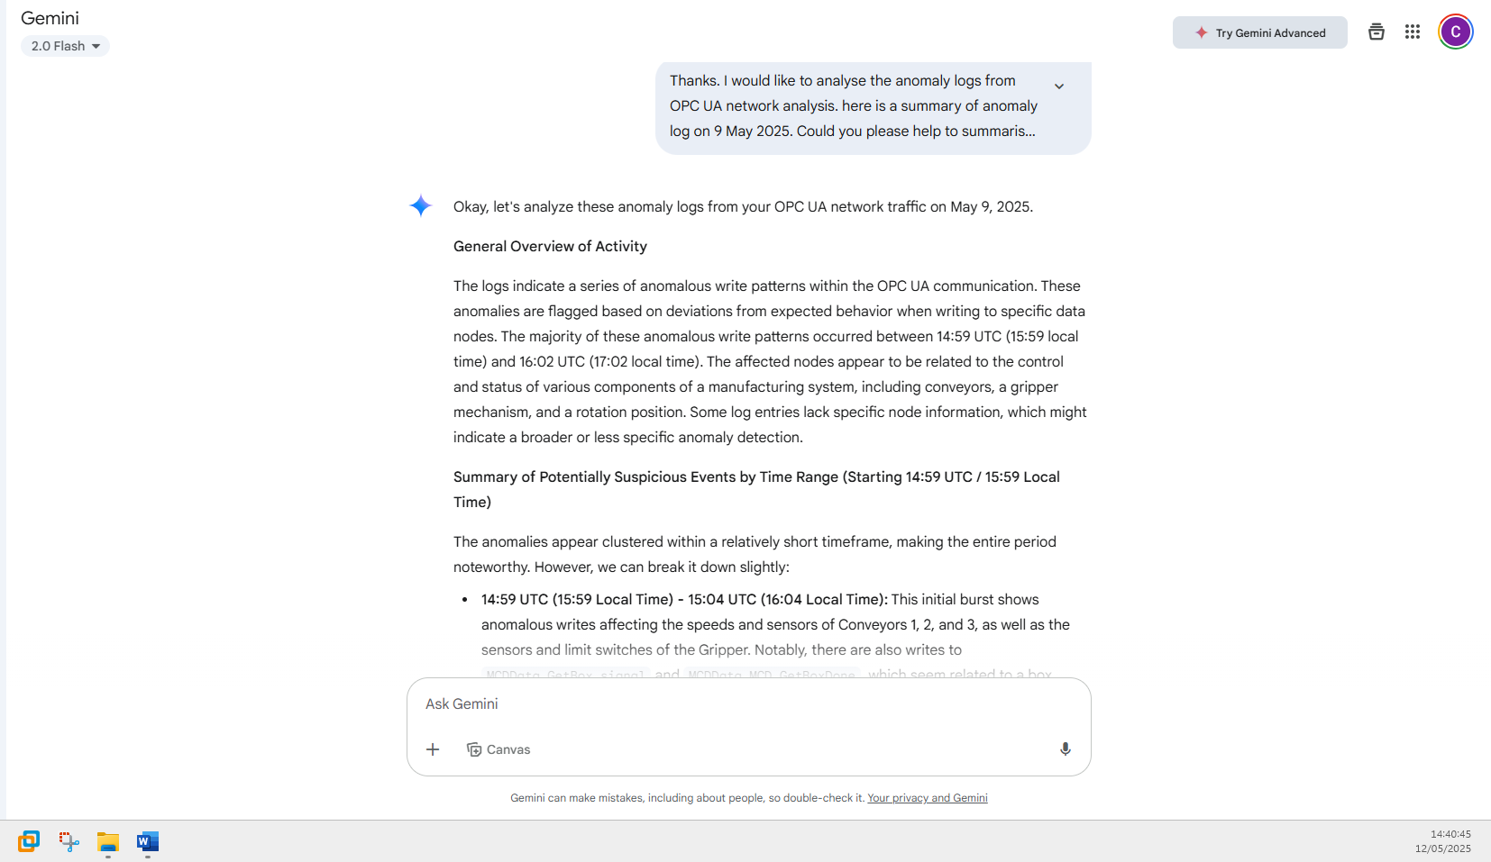

Thanks. I would like to analyse the anomaly logs from OPC UA network analysis. here is a summary of anomaly log on 9 May 2025. Could you please help to summarise the information, so that I could know what has happened during the 9 May 2025. Please give me a general overview of work happened. Then, please give me a summary of events based on time range that may be suspicious events happening. Here is the log: Anomalous OPC UA write patterns noted at 2025-05-09 14:59 (UTC Time) / 2025-05-09 15:59 (Local Time)
Explanation: OPC UA write to node(s): -, MCDData.Conveyor3_Sensor, MCDData.Conveyor1_Speed, MCDData.Conveyor2_Speed
------------------------------------------------------------
Anomalous OPC UA write patterns noted at 2025-05-09 15:00 (UTC Time) / 2025-05-09 16:00 (Local Time)
Explanation: OPC UA write to node(s): -, MCDData.Conveyor3_Speed
------------------------------------------------------------
Anomalous OPC UA write patterns noted at 2025-05-09 15:01 (UTC Time) / 2025-05-09 16:01 (Local Time)
Explanation: OPC UA write to node(s): -, MCDData.Gripper_Sensor, MCDData.Gripper_UP_Limit, MCDData.Gripper_LO_Limit
------------------------------------------------------------
Anomalous OPC UA write patterns noted at 2025-05-09 15:02 (UTC Time) / 2025-05-09 16:02 (Local Time)
Explanation: OPC UA write to node(s): -, MCDData.Gripper_Z_Speed
------------------------------------------------------------
Anomalous OPC UA write patterns noted at 2025-05-09 15:03 (UTC Time) / 2025-05-09 16:03 (Local Time)
Explanation: OPC UA write to node(s): -, MCDData.Gripper_Z_Speed, MCDData.Gripper_LO_Limit, MCDData.Gripper_UP_Limit, MCDData.Gripper_Sensor
------------------------------------------------------------
Anomalous OPC UA write patterns noted at 2025-05-09 15:04 (UTC Time) / 2025-05-09 16:04 (Local Time)
Explanation: OPC UA write to node(s): -, MCDData.GetBox_signal, MCDData.MCD_GetBoxDone, MCDData.Gripper_Z_Speed
------------------------------------------------------------
Anomalous OPC UA write patterns noted at 2025-05-09 15:10 (UTC Time) / 2025-05-09 16:10 (Local Time)
------------------------------------------------------------
Anomalous OPC UA write patterns noted at 2025-05-09 15:15 (UTC Time) / 2025-05-09 16:15 (Local Time)
------------------------------------------------------------
Anomalous OPC UA write patterns noted at 2025-05-09 15:16 (UTC Time) / 2025-05-09 16:16 (Local Time)
------------------------------------------------------------
Anomalous OPC UA write patterns noted at 2025-05-09 15:30 (UTC Time) / 2025-05-09 16:30 (Local Time)
------------------------------------------------------------
Anomalous OPC UA write patterns noted at 2025-05-09 15:43 (UTC Time) / 2025-05-09 16:43 (Local Time)
------------------------------------------------------------
Anomalous OPC UA write patterns noted at 2025-05-09 15:51 (UTC Time) / 2025-05-09 16:51 (Local Time)
------------------------------------------------------------
Anomalous OPC UA write patterns noted at 2025-05-09 15:52 (UTC Time) / 2025-05-09 16:52 (Local Time)
------------------------------------------------------------
Anomalous OPC UA write patterns noted at 2025-05-09 15:53 (UTC Time) / 2025-05-09 16:53 (Local Time)
Explanation: OPC UA write to node(s): -, MCDData.Conveyor2_Speed
------------------------------------------------------------
Anomalous OPC UA write patterns noted at 2025-05-09 15:54 (UTC Time) / 2025-05-09 16:54 (Local Time)
Explanation: OPC UA write to node(s): -, MCDData.Conveyor3_Speed
------------------------------------------------------------
Anomalous OPC UA write patterns noted at 2025-05-09 15:55 (UTC Time) / 2025-05-09 16:55 (Local Time)
Explanation: OPC UA write to node(s): -, MCDData.Conveyor3_Speed
------------------------------------------------------------
Anomalous OPC UA write patterns noted at 2025-05-09 15:56 (UTC Time) / 2025-05-09 16:56 (Local Time)
------------------------------------------------------------
Anomalous OPC UA write patterns noted at 2025-05-09 15:57 (UTC Time) / 2025-05-09 16:57 (Local Time)
Explanation: OPC UA write to node(s): -, MCDData.Conveyor3_Speed
------------------------------------------------------------
Anomalous OPC UA write patterns noted at 2025-05-09 15:58 (UTC Time) / 2025-05-09 16:58 (Local Time)
Explanation: OPC UA write to node(s): -, MCDData.GetBox_signal, MCDData.RotatePosition
------------------------------------------------------------
Anomalous OPC UA write patterns noted at 2025-05-09 15:59 (UTC Time) / 2025-05-09 16:59 (Local Time)
Explanation: OPC UA write to node(s): -, MCDData.RotatePosition, MCDData.Gripper_Z_Speed
------------------------------------------------------------
Anomalous OPC UA write patterns noted at 2025-05-09 16:00 (UTC Time) / 2025-05-09 17:00 (Local Time)
Explanation: OPC UA write to node(s): -, MCDData.RotatePosition
------------------------------------------------------------
Anomalous OPC UA write patterns noted at 2025-05-09 16:01 (UTC Time) / 2025-05-09 17:01 (Local Time)
------------------------------------------------------------
Anomalous OPC UA write patterns noted at 2025-05-09 16:02 (UTC Time) / 2025-05-09 17:02 (Local Time)

Individual Log Analysis - Process Log

Analysis – Process Anomaly
Alright, let's dive into the physical process anomaly logs from May 9, 2025.
General Overview of Activity
The logs provide insights into the predicted operational state of the physical processes and any associated alarms. For most of the logged period, the system predicts a "Normal_NoIntervention" state with high confidence. However, there are two distinct periods where anomalies are detected: one involving potential manipulation of conveyor speeds and another indicating a deviation in the gripper's rotation. Interestingly, during the "Conveyor_SpeedManipulation" events, no alarms were raised, suggesting the anomaly detection system identified deviations that didn't necessarily trigger predefined alarm thresholds. In contrast, the initial normal periods show the presence of high-speed alarms for Conveyor 2 and Conveyor 3, which the system seemingly categorized as normal operation requiring no intervention at those specific times.
Summary of Potentially Suspicious Events by Time Range (Starting 15:59)
We can identify two key time ranges with anomalous behavior:
- 16:03 - 16:07: This short but significant period is characterized by the system predicting "Conveyor_SpeedManipulation" with very high confidence (up to 100%). Despite these strong predictions of manipulation, no alarms were triggered. This discrepancy is noteworthy. It suggests that the system identified patterns indicative of intentional speed changes that fell outside the normal operational envelope but did not breach the defined alarm limits (e.g., perhaps gradual or coordinated speed adjustments). This could be a sign of unauthorized control or a subtle system issue.
- 16:58 - 17:01: This later period shows a shift in the type of anomaly detected. At 16:58 and 16:59, the system again predicts "Conveyor_SpeedManipulation" with high probability and without triggering alarms, similar to the earlier event. Then, at 17:00 and 17:01, the predicted label changes to "Gripper_RotationDeviation" with very high confidence. This indicates an unusual behavior in the gripper's rotation that the system flagged as an anomaly. The fact that this occurs after a period of conveyor speed anomalies might suggest a sequence of unusual events affecting different parts of the physical process.
In summary, the physical process anomaly analysis for May 9, 2025, highlights two periods of potential concern. The first, around 16:03 to 16:07, indicates likely manipulation of conveyor speeds that didn't trigger standard alarms. The second, between 16:58 and 17:01, shows a return of conveyor speed manipulation followed by a significant deviation in the gripper's rotation. The lack of alarms during these anomaly predictions doesn't negate their potential significance. Further investigation into the nature of these "manipulations" and "deviations" is warranted to determine if they represent normal but unusual operational changes, system malfunctions, or potentially malicious activity. The earlier high-speed alarms during periods classified as "Normal_NoIntervention" also deserve a closer look to understand why they didn't lead to a different predicted label.

Prompt to Gemini 2.0 Flash – Process Anomaly
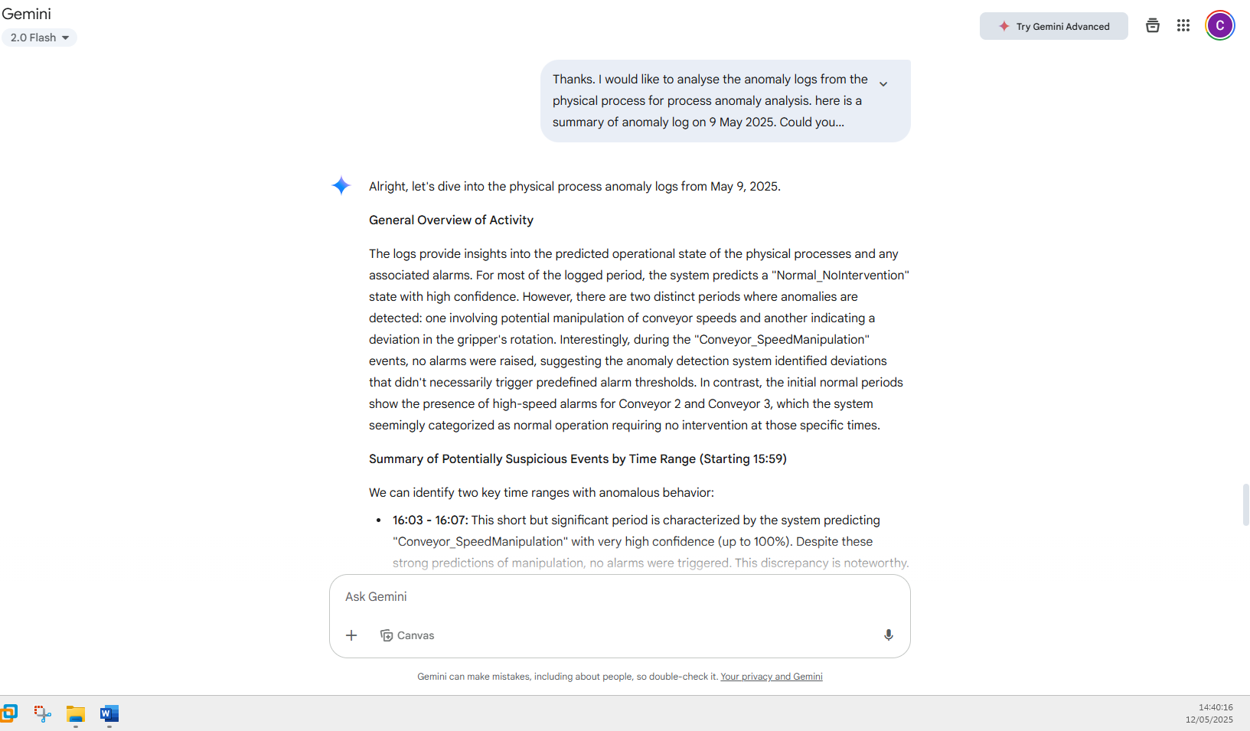
Thanks. I would like to analyse the anomaly logs from the physical process for process anomaly analysis. here is a summary of anomaly log on 9 May 2025. Could you please help to summarise the information, so that I could know what has happened during the 9 May 2025. Please give me a general overview of work happened. Then, please give me a summary of events based on time range that may be suspicious events happening. Here is the log: Time 2025-05-09 15:59
Predicted Label: 0 – Label 0: Normal_NoIntervention
Class Probabilities: Class 0: 100.00% | Class 1: 0.00% | Class 2: 0.00% | Class 3: 0.00% | Class 4: 0.00%
Alarm Count: 5, High Priority: 0
Sources: prov:default:/tag:Conveyor2_Speed:/alm:High Speed Alarm - Conveyor 2
------------------------------------------------------------
Time 2025-05-09 16:00
Predicted Label: 0 – Label 0: Normal_NoIntervention
Class Probabilities: Class 0: 99.99% | Class 1: 0.00% | Class 2: 0.01% | Class 3: 0.00% | Class 4: 0.00%
Alarm Count: 3, High Priority: 0
Sources: prov:default:/tag:Conveyor3_Speed:/alm:High Speed Alarm - Conveyor 3
------------------------------------------------------------
Time 2025-05-09 16:01
Predicted Label: 0 – Label 0: Normal_NoIntervention
Class Probabilities: Class 0: 100.00% | Class 1: 0.00% | Class 2: 0.00% | Class 3: 0.00% | Class 4: 0.00%
Alarm Count: 3, High Priority: 0
Sources: prov:default:/tag:Conveyor3_Speed:/alm:High Speed Alarm - Conveyor 3
------------------------------------------------------------
Time 2025-05-09 16:03
Predicted Label: 1 – Label 1: Conveyor_SpeedManipulation
Class Probabilities: Class 0: 2.79% | Class 1: 97.00% | Class 2: 0.05% | Class 3: 0.05% | Class 4: 0.11%
No alarm raised.
------------------------------------------------------------
Time 2025-05-09 16:04
Predicted Label: 1 – Label 1: Conveyor_SpeedManipulation
Class Probabilities: Class 0: 0.77% | Class 1: 98.17% | Class 2: 0.02% | Class 3: 1.03% | Class 4: 0.01%
No alarm raised.
------------------------------------------------------------
Time 2025-05-09 16:05
Predicted Label: 1 – Label 1: Conveyor_SpeedManipulation
Class Probabilities: Class 0: 0.05% | Class 1: 99.80% | Class 2: 0.00% | Class 3: 0.13% | Class 4: 0.02%
No alarm raised.
------------------------------------------------------------
Time 2025-05-09 16:07
Predicted Label: 1 – Label 1: Conveyor_SpeedManipulation
Class Probabilities: Class 0: 0.00% | Class 1: 100.00% | Class 2: 0.00% | Class 3: 0.00% | Class 4: 0.00%
No alarm raised.
------------------------------------------------------------
Time 2025-05-09 16:53
Predicted Label: 0 – Label 0: Normal_NoIntervention
Class Probabilities: Class 0: 99.37% | Class 1: 0.03% | Class 2: 0.52% | Class 3: 0.05% | Class 4: 0.04%
Alarm Count: 1, High Priority: 0
Sources: prov:default:/tag:Conveyor2_Speed:/alm:High Speed Alarm - Conveyor 2
------------------------------------------------------------
Time 2025-05-09 16:54
Predicted Label: 0 – Label 0: Normal_NoIntervention
Class Probabilities: Class 0: 99.99% | Class 1: 0.00% | Class 2: 0.01% | Class 3: 0.00% | Class 4: 0.00%
Alarm Count: 3, High Priority: 0
Sources: prov:default:/tag:Conveyor2_Speed:/alm:High Speed Alarm - Conveyor 2, prov:default:/tag:Conveyor3_Speed:/alm:High Speed Alarm - Conveyor 3
------------------------------------------------------------
Time 2025-05-09 16:57
Predicted Label: 0 – Label 0: Normal_NoIntervention
Class Probabilities: Class 0: 94.82% | Class 1: 4.64% | Class 2: 0.12% | Class 3: 0.25% | Class 4: 0.18%
Alarm Count: 2, High Priority: 0
Sources: prov:default:/tag:Conveyor3_Speed:/alm:High Speed Alarm - Conveyor 3
------------------------------------------------------------
Time 2025-05-09 16:58
Predicted Label: 1 – Label 1: Conveyor_SpeedManipulation
Class Probabilities: Class 0: 0.01% | Class 1: 99.78% | Class 2: 0.01% | Class 3: 0.02% | Class 4: 0.19%
No alarm raised.
------------------------------------------------------------
Time 2025-05-09 16:59
Predicted Label: 1 – Label 1: Conveyor_SpeedManipulation
Class Probabilities: Class 0: 0.01% | Class 1: 99.42% | Class 2: 0.00% | Class 3: 0.01% | Class 4: 0.55%
No alarm raised.
------------------------------------------------------------
Time 2025-05-09 17:00
Predicted Label: 4 – Label 4: Gripper_RotationDeviation
Class Probabilities: Class 0: 0.00% | Class 1: 0.13% | Class 2: 0.01% | Class 3: 0.02% | Class 4: 99.84%
No alarm raised.
------------------------------------------------------------
Time 2025-05-09 17:01
Predicted Label: 4 – Label 4: Gripper_RotationDeviation
Class Probabilities: Class 0: 0.01% | Class 1: 8.54% | Class 2: 0.04% | Class 3: 0.05% | Class 4: 91.35%
No alarm raised.
------------------------------------------------------------

